SHAMANIC APPRENTICE PROGRAM 2017

Cecile Carson, MD Rochester, NY

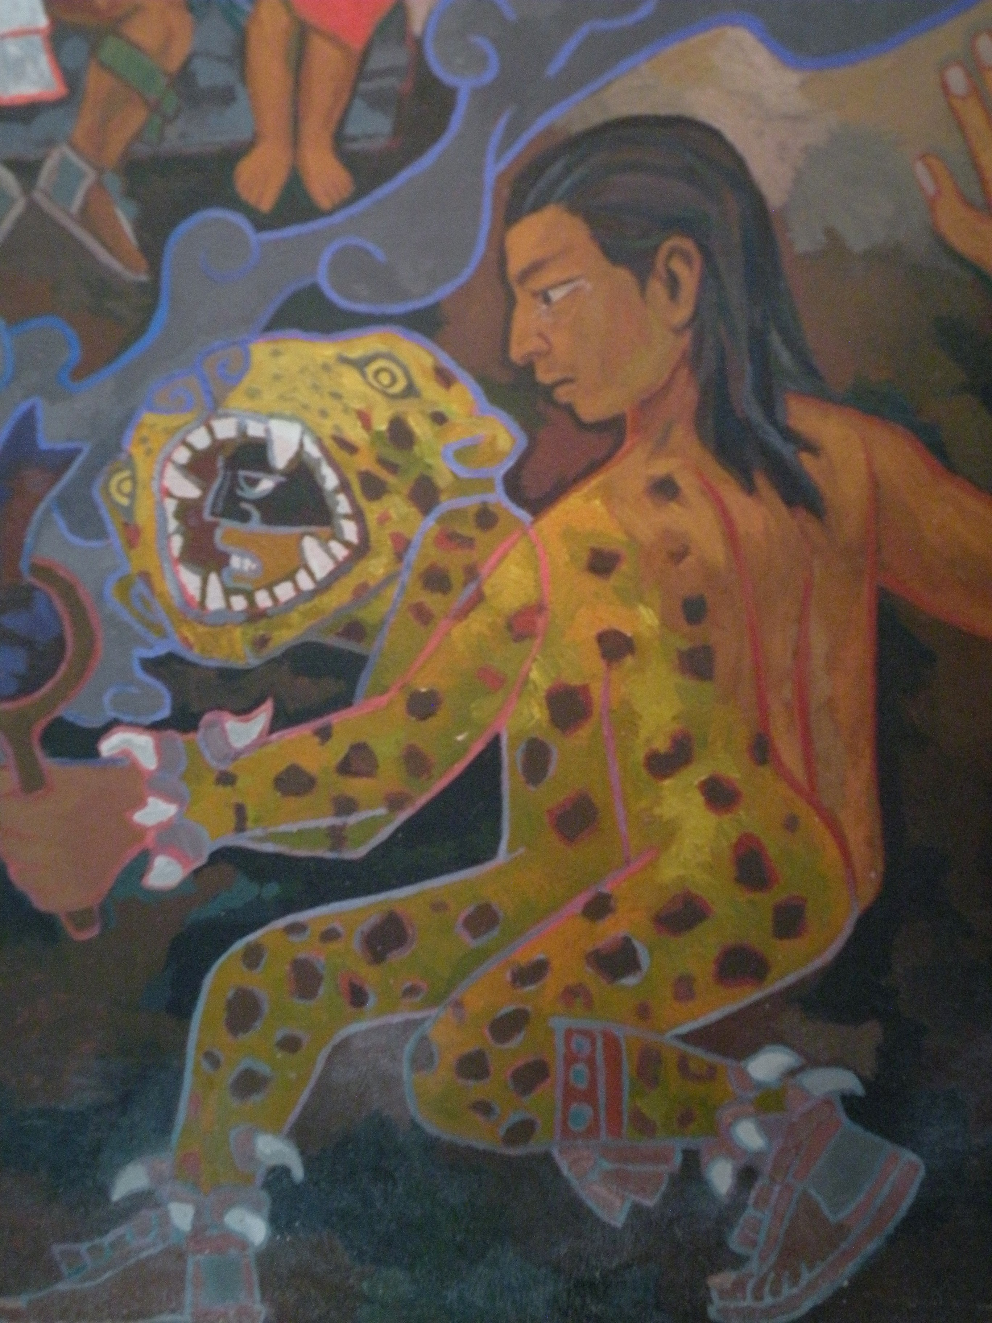
This one-year shamanic apprenticeship is for serious students of shamanism who wish to take their healing practice further. It requires that the participant have training in shamanic extraction, soul retrieval, and psychopomp methods and an intention to deepen their experiences of being a healing force in the world. The apprenticeship program also includes specific shamanic initiations to break open to deeper aspects of ourselves and widen the framework in which we understand and act in our world.

Taking shamanic work and community building beyond the local level is encouraged, too, especially through shamanic organizations and webinar trainings.

The training covers three 3-day intensives in spring, summer, and fall of 2017. (The summer session will be a 3-day vision quest in Honeoye, NY.)

Course content:
shamanic initiations
advanced spiritual protection
advanced work in shamanic tending of land and areas of traumatic events
advanced work creating ceremonies, ritual, and ritual objects
an independent shamanic project and write-up of this project

Dates & times: May 19, 20, 21; July 4, 15, 16 (off site in Honeoye, NY), and September 22, 23, 24. Each on-site day at Brighton Pathways to Health is 9-5, with an occasional evening ceremony.

Tuition: $1,250.

To apply: call 585-271-5650 or cecile@cecilecarson.com for an application. Once accepted, a non-refundable deposit of $250 is due and will hold your space in the group.

