Introduction to Core Shamanism: Returning Spirit to Our World
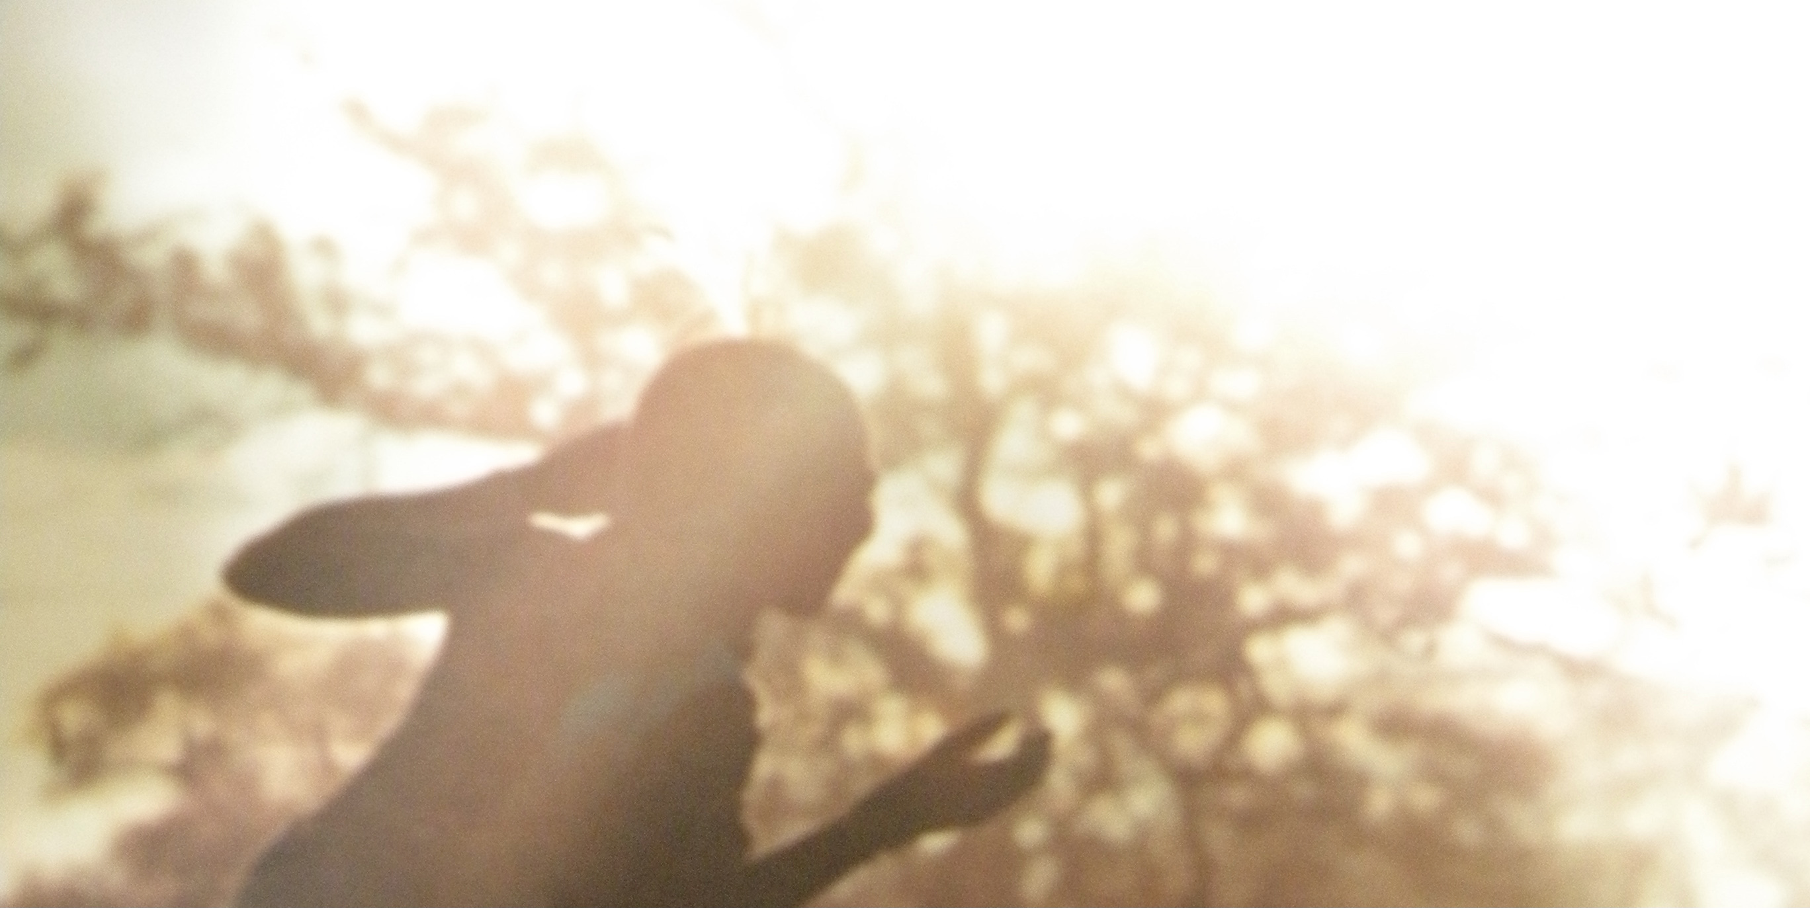
Cecile Carson, MD November 12-13, 2022 Lafayette, LA

Shamanism is the most ancient form of healing known. Cave paintings and ritual objects dated 12,000-40,000 years ago, found across all inhabited continents, attest to its potency. Throughout these millenia, humans have reached beyond their 3-dimensional world for survival, connection, and meaning. We all are their descendants, but in today’s Western culture, linear and scientific ways of knowing have come to be overemphasized as both primary and as the only way of knowing and healing, splitting us off from the world of spirit and soulful matters.

In our time together, we will be introduced to core shamanism, a non-indigenous spiritual methodology to access an even greater reality, “non-ordinary reality,” to help mend this split and bring home what our Ancestors knew: that everything is alive with spirit. We will learn the shamanic journey, a cross-cultural form of shifting consciousness beyond our 3-dimensional world, to meet our own personal spiritual allies who will guide us in accessing deeper ways of knowing and healing, for ourselves and all our relations: humans, animals, plants, and the environment.

For this in-person workshop, you will need an eye cover (bandanna, sleep mask), a small blanket or throw, warm socks or slippers, a rattle or hand drum (if you have them), and a journal. It is important to be free of mood-altering substances (caffeine okay) 24-48 hours prior to and during our time together, unless it is a necessary prescription medication.

Date & Times: November 12-13, 2022, 9:00 a.m. to 5:00 p.m. both Saturday and Sunday. Please be prompt, and on Saturday plan to arrive 20 minutes ahead of time to complete registration and set up your space. Camelia House, 708 Jefferson Ave, Lafayette LA 70501

Tuition & Registration: $195 (PayPal, check, or cash). A non-refundable deposit of $65 is required to hold your place in the workshop. Contact: Cecile Carson cecile@cecilecarson.com 585-271-5650.

Cecile Carson is a long-time international shamanic teacher and a practitioner of core shamanism. She was a Founding Board Member of the Society for Shamanic Practice and is editor of the anthology Spirited Medicine: Shamanism in Contemporary Healthcare.

