LIVING SHAMANICALLY II: A ONE-YEAR INTENSIVE

Rochester, NY May - September, 2017
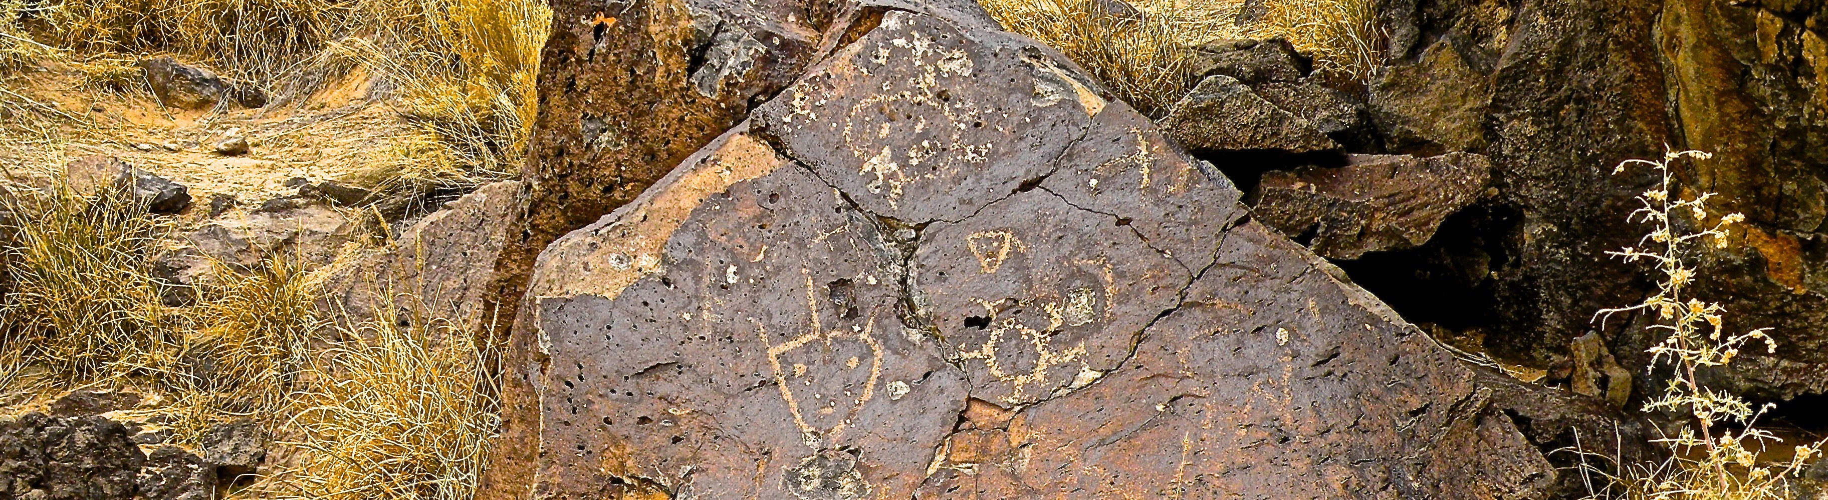
“It’s not what you do but who you become that changes the world.” —Sandra Ingerman

Living Shamanically Intensive Part II is a continuation of Part I of the previous year’s training, extending the spiritual reach of participants. The three weekend sessions include:

Creativity & Community, Transfiguration & Transmutation

Shapeshifting and Manifesting Dreams

Stalking Your Soul’s Purpose, Meeting Your Shadow Self

Finding Your Life in Service, Sacred Contracts, Ritual & Ceremony

Dedication, Consecration, and Celebration of Your Life

CONTACT: Cecile Carson, MD www.cecilecarson.com 585-271-5650

TUITION: $1,250

DATES & Times: May 12, 13, 14; July 21, 22, 23; September 15, 16, 17 of 2017;
9 am - 5 pm each day

LOCATION: Brighton Pathways to Health, 3200 Brighton-Henrietta Town Line Road, Rochester, NY, 14623

If interested, please contact Cecile for an application. If accepted into the training, a $200 non-refundable deposit will become due and will secure your spot in the group.

